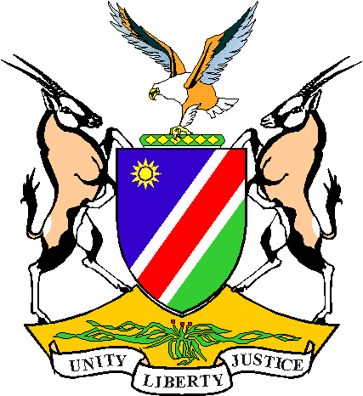
To:
The Mining Commissioner
Ministry of Mines and Energy
Private Bag 13297
Windhoek

Fax: 061 2848299/

238643
Received:

(MME date stamp)

REPUBLIC OF NAMIBIA

MINISTRY OF MINES AND ENERGY
DATE:
NOTIFICATION
OF INTENTION TO DRILL

In terms of section 53. (1) of the Minerals (Prospecting and Mining) Act of 1992, the holder of the following licence:
LICENCE NO. | TYPE | HOLDER

Hereby wishes to inform you of the intention to drill the following bore holes:

Borehole Number | Type | Location in Decimal Degrees |  | Angle | Direction | Expected Depth in metres | Expected Date of Completion
Borehole Number | Type | Latitude | Longitude

Drilling Contractor to be used:

Completed by : (Print Name)
Signature:
Capacity:

N.B. Comprehensive report to be forwarded on completion of programme.

